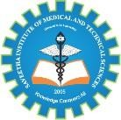

SIMATS ENGINEERING

Saveetha Institute of Medical and Technical Sciences
Chennai- 602105

Student Name: S. Yuva Guru Mani Varma Reg. No.: 192425005
Course Code: ITA0504 Slot: C
Course Name: Computer Vision
Course Faculty: Dr. MATHIVANAN P

Project Title: Real-Time Hybrid Sign Language Recognition System with Smart Audio Synthesis
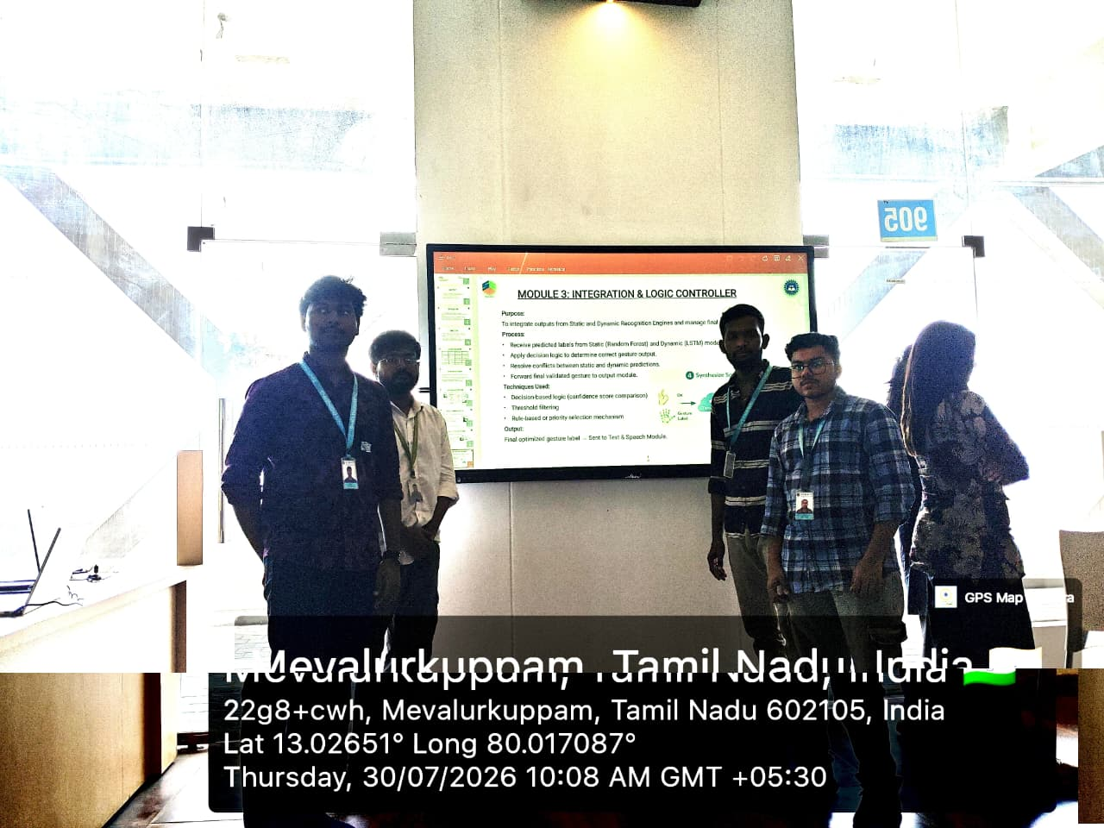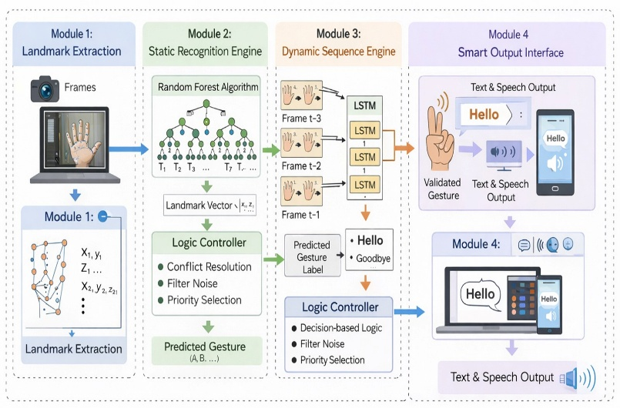

Project Description: This module focuses on developing a real-time hybrid sign language recognition system that identifies hand gestures and converts recognized signs into meaningful text and synthesized speech.This module focuses on continuously capturing and analyzing sign language gestures using computer vision and machine learning techniques.
- Captures hand gestures through a camera in real time.
- Detects and tracks the user's hand movements and gesture patterns.
- Extracts relevant visual and spatial features from the captured hand signs.
- Uses a hybrid recognition approach to classify different sign language gestures accurately.
- Converts the recognized signs into corresponding text or words.
- Maintains the recognized sequence to form meaningful phrases or sentences.
- Uses smart audio synthesis to convert the generated text into natural speech.
- Provides real-time feedback through text and audio output.
Output: Real-time sign language recognition with text and synthesized audio output.

Student Signature Guide Signature

